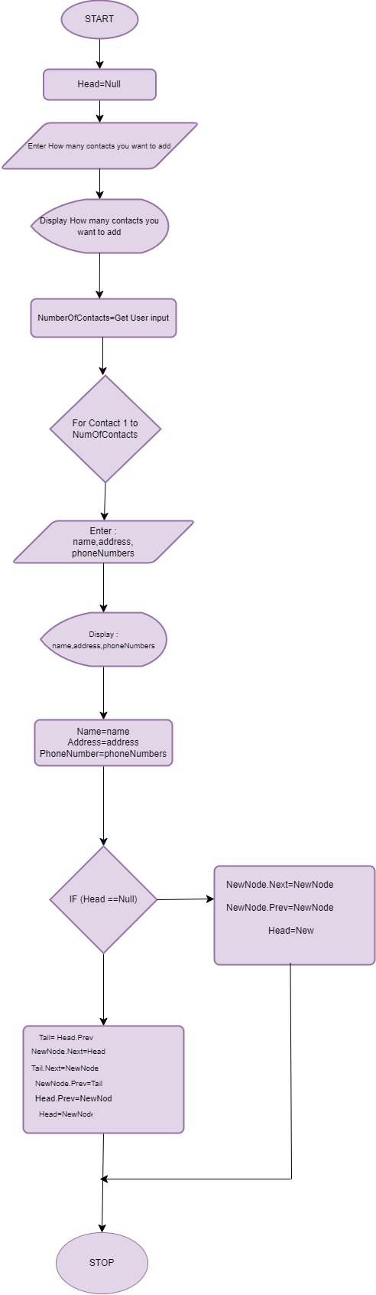phoneBookListA flowchart

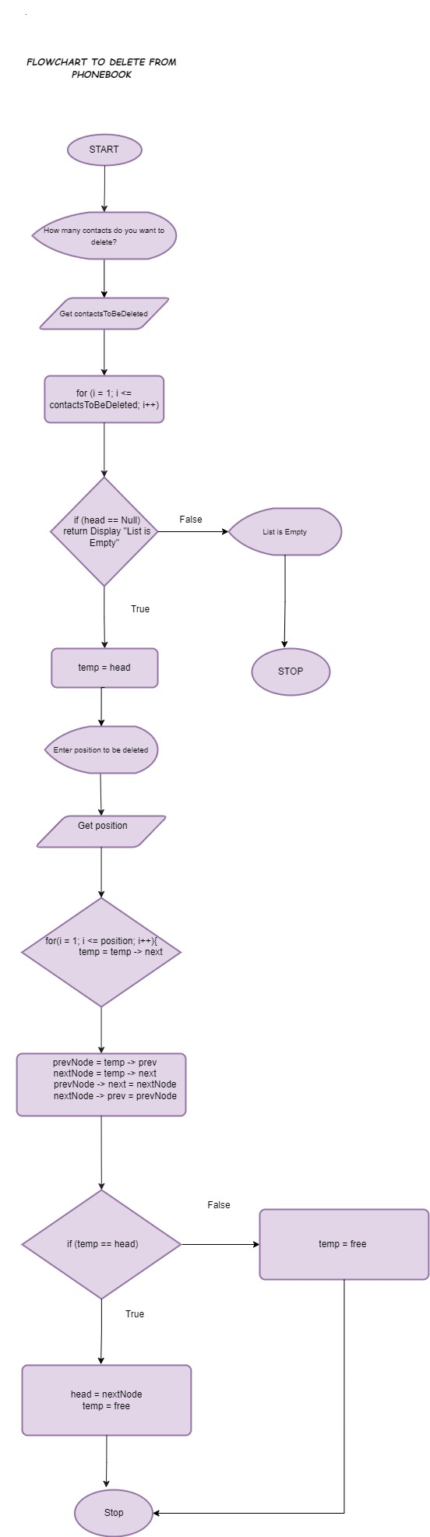Flowchart Delete from phone book

Flowchart to Search contact by name

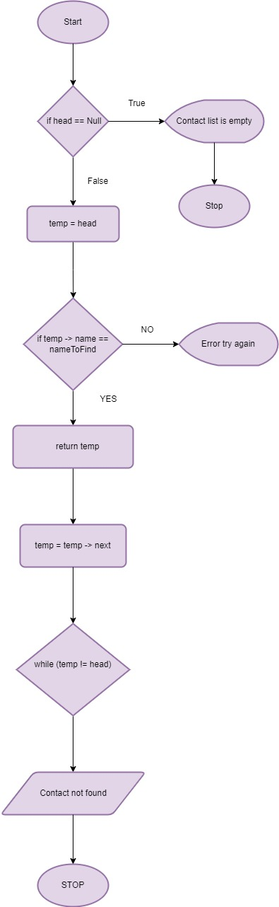

Flowchart to split nodes

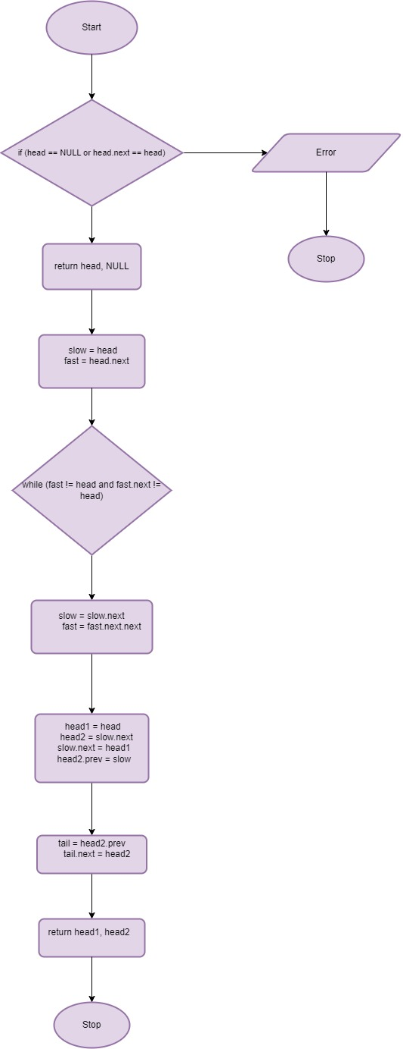

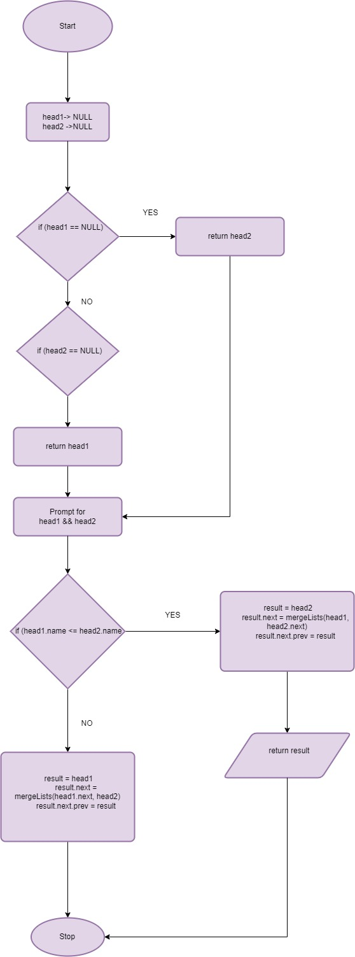MergeList Flowchart

Flowchart for merge sort

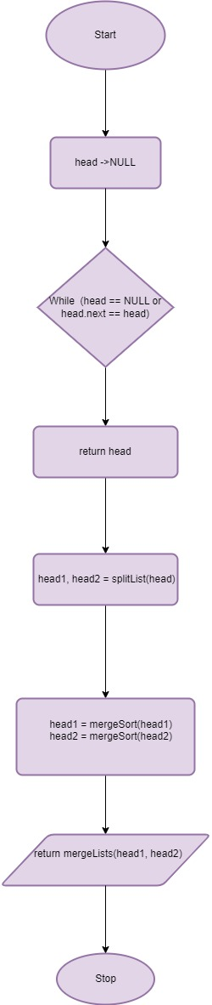

DisplayAllContact Flowchart

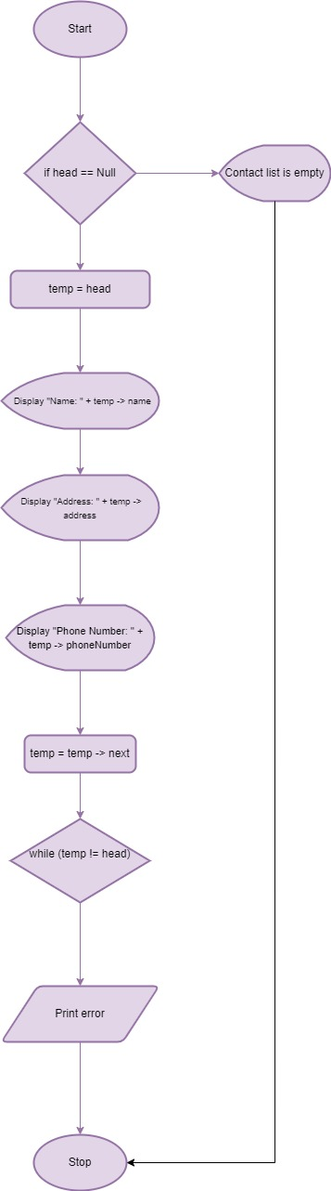

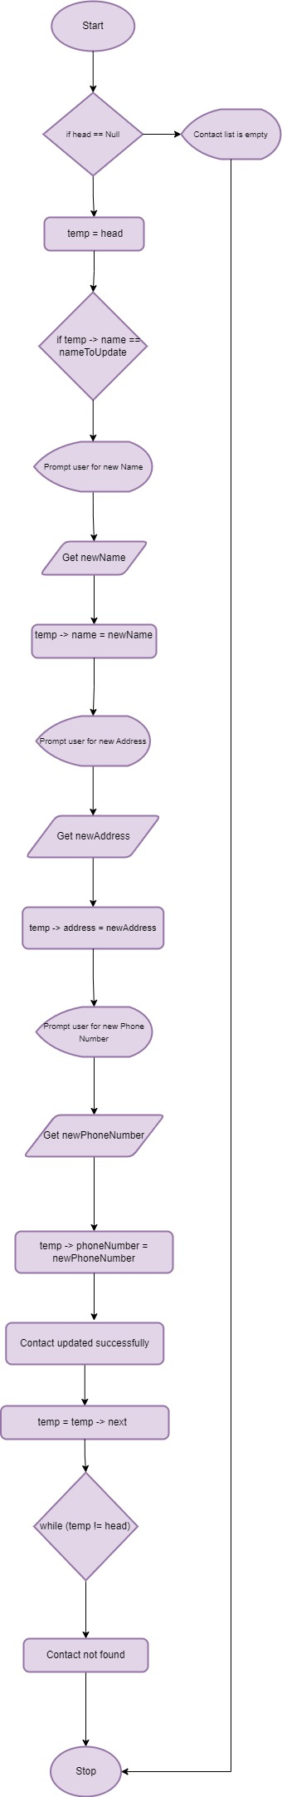UpdateContact Flowchart